Idea
The idea is to build a blog using Django that I will use to write stuff down. I always want to write, whether it be articles about politics, thoughts on the game I'm playing, or philosophical things based on the books that I have been reading. I also want to get better and have more projects using Django. So I will build a blog.

Reason
I am doing the project this way, since when I was in school using this approach worked well and I actually finished things. Since I am now working on my own again, I have noticed that I'm not really able to finish stuff as easily, and I don't have the best gameplan of what to do when things go awry. So I am going to use the approach that I used for writing reports at UoL.

Gameplan
I will use Django. I need to design a database, models, using SQLite. I am using SQLite instead of PostGreSQL because I want to focus on have the blog up and running. I'm going to use a Gannt chart, but first I need to have a very nice idea of how the site will look and how long it will take everything to be up and running. I think I'll just start with invision, and design the front end, and then hook up all the back parts using Django. I can reuse some of the stuff that I already built using the other Django project.

Users can login in order to comment on posts. The front end will look slightly different depending on if the user is logged in or not. AJAX will be used in order to load the comments from the database. The 10 most recent articles will be displayed. This will be done in the backend, with backend calls using a REST API depending on the page number that the user clicks on the site. Bootstrap will also be used for the front end.

Things I may implement later down the road
  - NLP stuff to auto tag
  - Ability to upload media onto the articles to make them a little more dynamic
  - Search functionality for articles
  - Set up static files, hosting at Digital Ocean

First things first, set up a new Django Application, and get all of the my requirements set up. I'll have a basic gameplan of what I want to accomplish, using a Gannt chart. So here are the steps that I will need to add onto the Gannt chart:
  - Set up Django Project
  - Create front end using bootstrap (user login included here)
  - Create views/APIs that can be accessed using AJAX to show recent articles dynamically
  - NLP auto tagging/Search
  - Static files/digital ocean hosting.

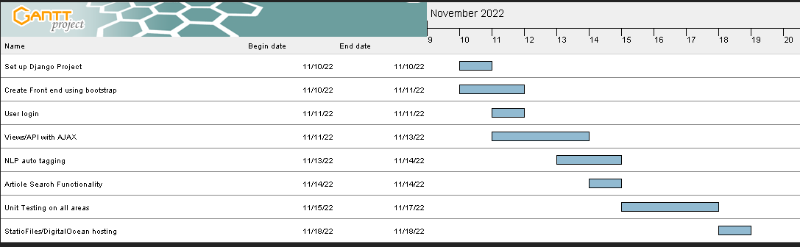

I will have two models, an Article and Comment model.

Implementation

    - Day 1 -
      - First off, I need to set up everything on Pcloud so that it is accessible on my other computer. Then I'll create a new private Git repository, and checkout a new branch and do things this way.
    - Day 2 – Things went pretty well today. I got ajax working, and recreated the entire frontend in Django from the old project.
    - Gameplan for today – Get the comments section and articles working using AJAX, and th td data instead of accordion cards. Will have to do some design front end work in order to have buttons and event handlers set up to trigger the AJAX. Set up the ajax front end that can load articles, with some basic styling. Not going to implement comments in the front end for now. Tomorrow, we will continue working on the multipage, and set up some NLP stuff in the backend.

